**TECHNICAL SPECIFICATION DOCUMENT**

**Customer Ageing Report**

**Requirement:** Develop a Customer Ageing Report by accepting a range of Document date and generating output as Customer Number, Name, City, Accounting Document Number, Company Code, and buckets to display amount for pending invoices.

**Selection Screen Fields:**

|  |  |  |  |  |
| --- | --- | --- | --- | --- |
| Description | Field | Table | Parameter/Range | Mandatory |
| Document Date | BLDAT | BSID | Range | Yes |

**Selection Screen Layout:** Enter a range of Document Date.

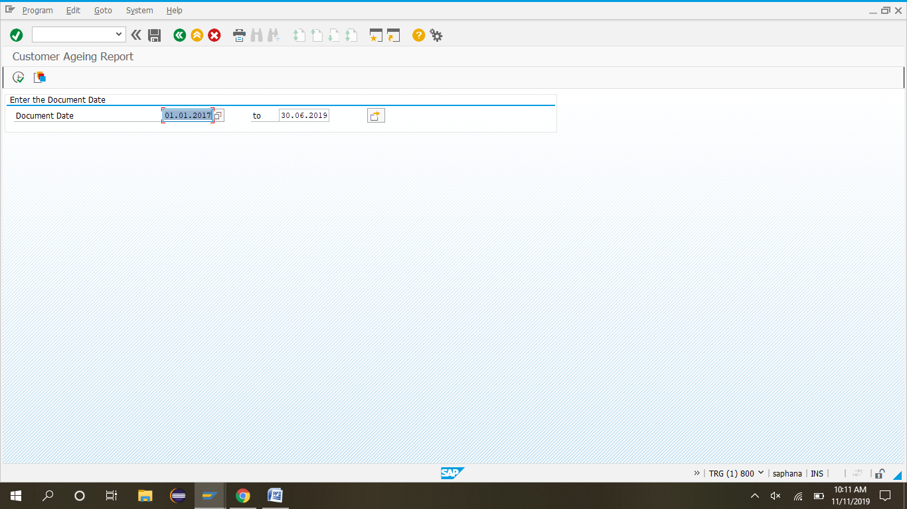

**Selection Screen Validations:**

1. Validate Document Date (BLDAT) with BSID-BLDAT

Check for existence of the Document Date value in BSID database table, and if not found display an appropriate error message.

  DATA L_BLDAT TYPE BSID-BLDAT.  
  SELECT SINGLE BLDAT  
     FROM BSID  
      INTO L_BLDAT  
     WHERE BLDAT IN S_BLDAT.  
  IF L_BLDAT IS INITIAL.  
   MESSAGE 'No Document Dates for the given range' TYPE 'I' DISPLAY LIKE 'E'.  
 ENDIF.

**Report Fields:**

|  |  |  |  |  |
| --- | --- | --- | --- | --- |
| **Field Name** | **Field Description** | **Length/ format** | **Sort** | **comments** |
| BUKRS | Company Code |  |  |  |
| BELNR | Accounting Document Number |  |  |  |
| BLDAT | Document Date |  |  |  |
| **DMBTR** | **Amount In Document**  **Currency** |  |  |  |
| KUNNR | Customer Number |  | Y |  |
| NAME1 | Customer Name |  |  |  |
| ORT01 | City |  |  |  |

**Tables Involved:** BSID, KNA1

**Report Flow:**

Display

NO Message

Yes

(Fetch Data from BSID and KNA1)

Validation

KNA1

BSID

Fetch Data

**Pseudo Code:**

**Step 1:** SELECT A~BUKRS

A~BELNR

A~BLDAT

A~DMBTR

B~KUNNR

B~NAME1

B~ORT01

FROM BSID AS A INNER JOIN KNA1 AS B

ON A~KUNNR = B~KUNNR

INTO CORRESPONDING FIELDS OF TABLE T_FINAL

WHERE A~BLDAT IN S_BLDAT.

**Step 2:** Get the difference of days between Document date and System Date using function Module.

CALL FUNCTION 'FIMA_DAYS_AND_MONTHS_AND_YEARS'  
      EXPORTING  
        I_DATE_FROM = W_FINAL-BLDAT  
*\*       I_KEY_DAY_FROM       =*  
        I_DATE_TO   = SY-DATUM  
*\*       I_KEY_DAY_TO         =*  
*\*       I_FLG_SEPARATE       = ' '*  
      IMPORTING  
        E_DAYS      = W_FINAL-DAYS.  
*\*     E_MONTHS             =*  
*\*     E_YEARS              =*

Step 3: Loop to assign amount into buckets based on outstanding days.

LOOP AT T_FINAL INTO W_FINAL.  
    IF W_FINAL-DAYS LE 500.  
      MOVE W_FINAL-DMBTR TO W_FINAL-DAY1.  
      MODIFY T_FINAL FROM W_FINAL.  
    ELSEIF W_FINAL-DAYS GE 500 AND W_FINAL-DAYS LE 1000.  
      MOVE W_FINAL-DMBTR TO W_FINAL-DAY2.  
      MODIFY T_FINAL FROM W_FINAL.  
    ELSEIF W_FINAL-DAYS GE 1000 AND W_FINAL-DAYS LE 1500.  
      MOVE W_FINAL-DMBTR TO W_FINAL-DAY3.  
      MODIFY T_FINAL FROM W_FINAL.  
    ELSEIF  W_FINAL-DAYS GE 1500 AND W_FINAL-DAYS LE 2000.  
      MOVE W_FINAL-DMBTR TO W_FINAL-DAY4.  
      MODIFY T_FINAL FROM W_FINAL.  
    ELSEIF W_FINAL-DAYS GE 2000.  
      MOVE W_FINAL-DMBTR TO W_FINAL-DAY5.  
      MODIFY T_FINAL FROM W_FINAL.  
    ENDIF.  
  ENDLOOP.

**Positive Test Case:**

30.06.2019

01.01.2017

Document Date : 3 to

**Output:**

